

DESIGN AND DEVELOPMENT OF ALICE CRU USER LOGIC
FIRMWARE FOR THE MID READOUT CHAIN

A thesis submitted to the Faculty of Engineering and Built Environment,
Cape Peninsula University of Technology,
in fulfilment of the requirement for the degree of
Master of Engineering in Electrical Engineering

Prepared by

DIEUVEIL ORCEL THYS-DINGOU
214349721

Supervisor

Dr. ATANDA RAJI

Co-supervisor(s)

Prof. E.Z. BUTHELEZI,
Dr. S.V. FöRTSCH

Bellville

June 2021

CPUT copyright information
The thesis may not be published either in part (in scholarly, scientific or technical journals), or as a whole (as a monograph), unless permission has been obtained from the University

DECLARATION

I, Dieuveil Orcel Thys-dingou, declare that the contents of this thesis represent my own unaided work, and that the thesis has not previously been submitted for academic examination towards any qualification. Furthermore, it represents my own opinions and not necessarily those of the Cape Peninsula University of Technology.

Signed: ________________ Date: ____________________

ABSTRACT

ACKNOWLEDGEMENTS

TABLE OF CONTENTS

If you are an accomplished user of Microsoft Word, you can type your thesis using STYLES, and generate an automatic Table of Contents. If not, use the template below. This gives you an indication of section and sub-section numbering. Do the Table of Contents right at the end, otherwise you will have to update it continuously.

Make sure that your headings are exactly the same as those in the text (use of sentence case and title case also). Sentence case is less confusing, easier to use and looks more modern and professional. Align page numbers on the right. This means typing the Table of Contents within a table so that page numbers can be aligned right. Use single or 1.15 line-spac

Abbreviation/Acronym

CERN - European Organization for Nuclear Research

ALICE - A Large Ion Collider Experiment

MID - Muon Identifier

ISO - International Organization for Standardization

CHAPTER 1

Introduction

1.1 Background

1.1.1 ALICE experiment

CERN is the world’s leading laboratory for scientific research located on the border of Switzerland and France. CERN houses the Large Hadron Collider (LHC). The LHC is about 100 meters below the surface and 27 kilometres in circumference. It produces particle beams i.e. proton-proto (p-p), proton-lead (p-pb) and lead-lead (pb-pb) at ultra-relativistic energies to create, amongst other, a highly dense form of matter reminiscent of the early universe a microsecond after the big bang. Spread along the LHC ring are four individual experiments positioned around the four collision points where the beams collide. As shown in Figure 1.1, one of these experiments is A Large Ion Collider Experiment (ALICE).
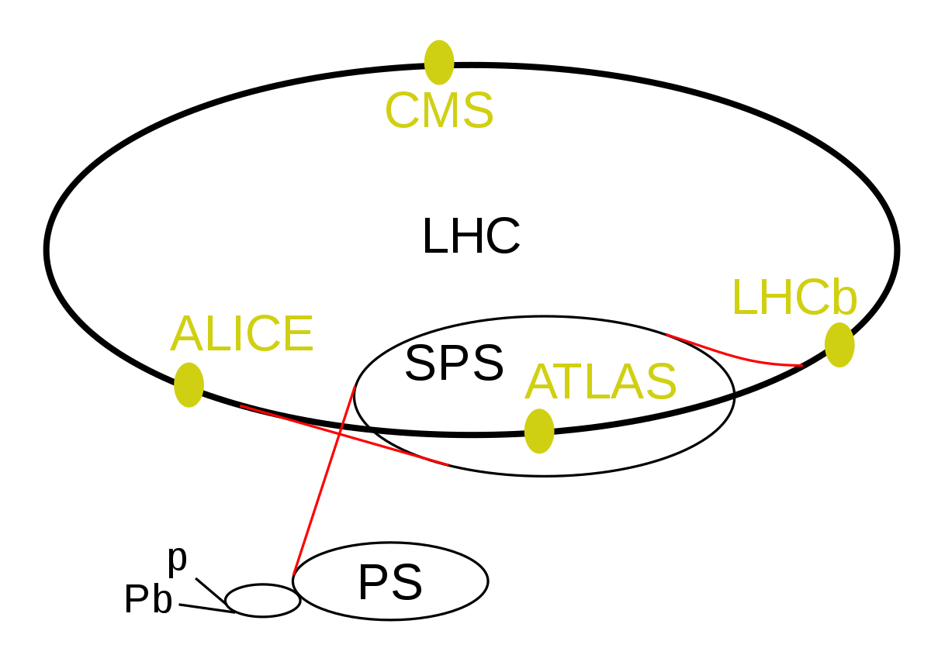

1.1.2 Physics goals

For few millions of seconds after the big bang, the universe consisted of hot soup of elementary particles called quark and gluons. A few microseconds later, those particles began cooling to form protons and neutrons, the fundamental of matter. Over the past decades, scientists around the world are trying to re-create that soup, known as the Quark-Gluon Plasma (QGP) by smashing particles together with enough energy to produce a temperature higher than the centre of the sun. By keeping the temperature and the density high enough, scientists can obtain a new phase of matter where quarks and muons are deconfined to QGP, such conditions can be created in high energy heavy-ion collisions at the CERN LHC more precisely in the ALICE experiment. ALICE is the only detector at the CERN LHC dedicated to the study of interacting matter, in particular the properties of the QGP.

1.1.3 Detector and sub-detectors

In order to reconstruct and identify a myriad of particles created in the collisions, the ALICE detector shown in Figure 1.1, is using a set of 19 sub-detectors extended over a length of 26m and 16m in height and width, weighing over 10 000 tons. The sub-detectors provide information about the mass, the velocity and the electrical sign of the particles and each is designed to study a different aspect of the particles created in the collisions.

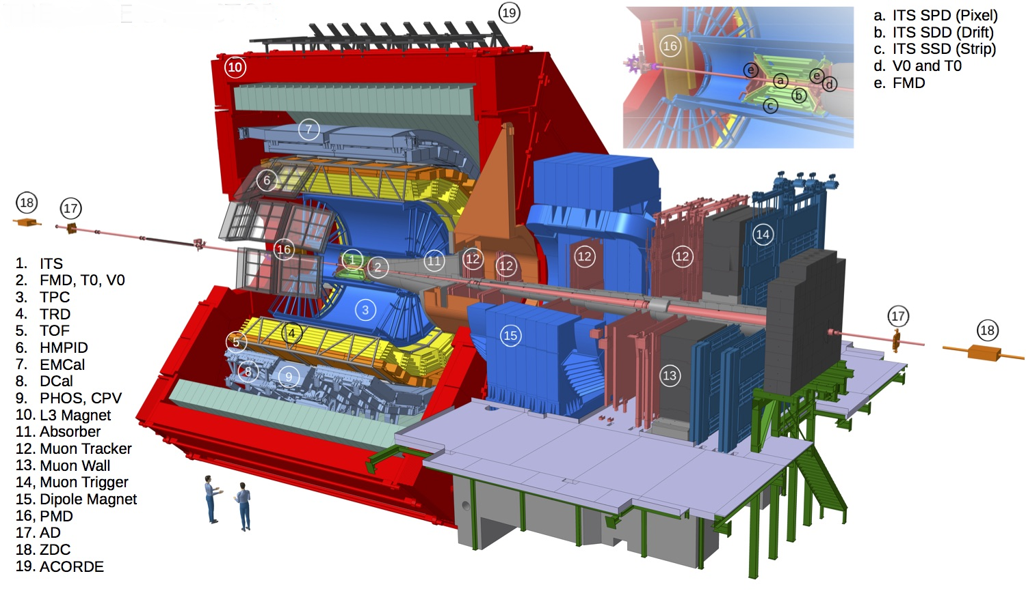

ALICE detector consists of two main regions: the central barrel region and the forward region known as the muon spectrometer.
The central barrel is covered by a solenoid L3 magnet, and it contains the Inner Tracking System (ITS) composed of six layers of silicon detectors: Silicon Pixel Detector (SPD), Silicon Detector Drift (SDD) and Silicon Strip Detector (SSD). The ITS is enveloped by a circular Time Projection Chamber (TPC), three particles identification arrays of Time of Flight (TOF), a ring imaging of Cherenkov High Momentum Particle Identification Detector (HMPID) and a Transition Radiation Detector (TRD). The surface layer contains the Electromagnetic Calorimeters (EMCal), and the Photon Spectrometer (PHOS). Small-scale sub-detectors used for global event identification and triggering such as the Zero Degree Calorimeter (ZDC), Photon Multiplicity Detector (PMD), Forward Multiplicity Detector (FMD), T0 and V0 are located away from the interaction point. On the three upper faces of the solenoid L3 magnet is A Cosmic Ray Detector (ACORDE). It consists of an array of plastic scintillator counters and together with the muon spectrometer, they provide accurate information about cosmic rays.

The muon spectrometer is designed to measure muon production from the decays of quarkonia, low mass vector mesons, heavy flavor hadrons and bosons. The quarkonia is detected in their dimuon decay channel in the angular acceptance of 171˚- 178˚, corresponding to the pseudo rapidity region −4.0 < η < −2.5 [ ]. The muon spectrometer covers a total length of ≃ 17 m and it is composed of the following components: absorbers to filter all particles except muons coming from the interaction point, a large dipole magnet, a high-resolution muon tracker, a 120 cm thick iron wall (muon filter), and a muon trigger.

The muon trigger is the former name given to the muon identifier prior the upgrades. Further technical details concerning the muon trigger will be described in details in the next sections as the work described in this thesis, is solely focused on this specific sub-detector.

1.1.4 Muon Trigger

The muon trigger system is designed to study high muons produced in heavy quarkonium and open heavy flavour meson decays. Equipped with a configurable threshold, the sub-detector is able to provide trigger signals to select events of interest and to discard events with only low muons. The muon trigger is based on 72 single gap Resistive Plate Chamber (RPC) detectors with x-y read-out, arranged in 2 stations of 2 chambers each at a distance of about 16 m and 17 m from the interaction point respectively. Each RPC consists of two planes, a positively-charged anode and a negatively-charged cathode, both made of very high resistivity plate plastic material and separated by 2 mm of gas. Once a charged particle such as a muon passes through the chamber, electrons are knocked out of the gas atoms. These electrons in turn hit other atoms causing a mass of electrons. The electrodes are transparent to the electrons, which are instead picked up by external metallic strips outside the chamber after a small but precise time delay. The pattern of hit strips gives a quick measure of the muon momentum, which is measured by the Front-End Electronics (FEE) known as A DUaL Threshold (ADULT) cards [ ]. The signals from the ADULT cards are then propagated to the readout electronics based on three programmable circuits (local, regional and global) working in pipeline mode at 40 MHz, to make immediate decisions about the validity of the data. The ADULT electronics were initially developed for streamer mode operation with a gas mixture of Ar, CH2F4, C4H10 and SF6 for the LHC Run 1 (2010-2012) [ ]. Few years later, a maxi-avalanche operation mode was introduced for the LHC Run 2 (2015-2018) [ ], where the signal amplitude is smaller than the streamer mode, but still compatible with the minimum threshold (≈ 7 mV) set in the ALDULT cards.

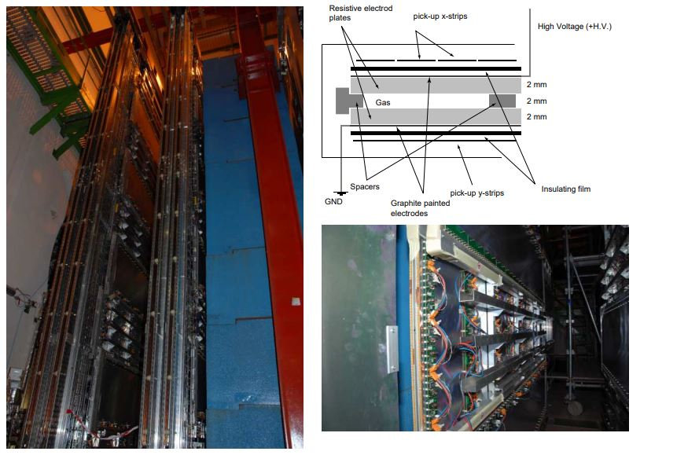

Left: view of the two trigger stations sitting behind the muon filter. Right-top: schematic view of an RPC cross section. Right-bottom: an individual RPC module equipped with the ADULT electronics

1.2 LHC Run 3 upgrades

Based on data collected in Run 1 and 2 (~10 petabytes of raw data) [ ], ALICE is the leading heavy-ion experiment in the world and is quickly expanding the knowledge gathered in previous experiments all over the world. ALICE is currently going through three years planned second Long Shutdown called (LS2) that has started in 2018 to prepare for Run 3. At the centre of the ALICE upgrade strategy is a high-speed readout approach based on a Common Readout Unit (CRU). The CRU has been developed for detector data readout, concentration, reconstruction, multiplexing and data decoding onto the online-offline (O²) computing system.

The LHC Run 3 is foreseen to start from 2021 onwards and it is predicted to have a peak luminosity of 6×1027 cm² per second. Many of the proposed observables require a shift in the data taking strategy, moving away from triggering a small subset of events to online processing and recording of all collisions delivered by the LHC. To achieve these goals, ALICE detector is being upgraded in such a way that all interactions will be inspected. The upgrade entails the replacement of some sub-detectors while most others including the muon trigger, are moving to new front-end electronics and readout system to allow all detectors to be read out at near the expected interaction rate up to 50 kHz lead-lead (Pb-Pb) collisions per second.

1.2.1 Muon Trigger to Muon Identifier

For the past 10 years since the LHC Run 1, the selection of single muon and di-muon events with a maximum trigger rate of 1 kHz has always been provided by the muon trigger [ ], however, to cope with the increased luminosity of the LHC during Run 3, this current trigger strategy is no longer sufficient. The upgrade trigger strategy does not require a muon trigger, since all event of interests will be read out upon the interaction trigger before online selections. As part of the upgrade, the existing muon trigger sub-detector has been renamed to the muon identifier (MID).

The transition from MTR to MID during the LS2 entails, the replacement of the RPC ADULT electronics by a new ASICS called the Front-End Electronics Rapid Integrated Circuit (FEERIC). Unlike ADULT, FEERIC performs amplification of the analogue signals from the RPCs. The RPCs will be operated in avalanche mode with a significant reduction of the charge produced in the gas, hence limiting ageing effects. Furthermore, in order to cope with the given readout rates, both the local and regional readout cards have been redesigned. Since the triggering functionalities are abandoned, a simplified design has been implemented. The hardware implementation of the regional and local card is identical, reducing the design and production effort by re-using the same hardware and adapting the FPGA firmware. The global crate has been replaced by a regional crate equipped with backplane bus card that serves as interface between the regional and local cards.

1.3 Problem statement

Few problems occurred during the transition from the MTR to MID. These problems were observed throughout a preliminary series of tests conducted on the MID readout chain. The upgraded system revealed drawbacks when running without data pre-analysis performed in the CRU firmware level. Among these drawbacks are: large data rate, failure to process data from the entire front-end system and desynchronization of data.

A data rate of 6.4 Gbps is produced by each regional crate of the readout chain. This vast volume of data is a problem for the O² computing system to conduct data processing concurrently without data compression at the CRU firmware level. Furthermore, the MID sub-detector is expected to read out data from collisions every 20 μs and the regional crate transmits data to the CRU every 25 ns. This means 8 Mbps out 6.4 Gbps are valuable data. The remaining data is meaningless and must be suppressed. Holding these data in the memory leads to poor efficiency and wasteful use of memory.

The O² computing system is capable of handling the data rate from a single regional crate at the expense of 2 core processors. Attempting to use one core to decode a single crate leads to irreversible data loss. Hence, it takes 2 core processors to decode a single crate. However, the computer used in the readout chain contains 20 core processors [ ]. In order to decode data from the entire front-end system, the computer would need 32 core processors, not to mention any additional cores required to perform further processing of the decoded data. This makes it impossible for a single computer to process data from the entire front-end system.

Lastly, data obtained from all the front-end electronics occurs simultaneously, at fixed periods and is transmitted over a wide spectrum of electrical and optical links. However, differing transmission delays result in the data from the various links to lose synchronization when transmitted to the O² computing system.

1.4 Research aim

The ALICE collaborators involved in the MID project are searching for alternative ways to process data. Many various solutions have been proposed to improve data processing of the readout chain, but most of them require major changes in the current readout chain, such as redesigning the software algorithm incorporated in the O² computing facility to cope with the large data rate and acquiring extra CRUs and computers to process data from the entire front-end system. A thorough analysis review revealed that the most efficient and cost-effective solution is to design a customized user logic firmware.

The user logic is a specific sub-detector component, that can be implemented into the CRU firmware through a specific compilation [ ]. It is developed by the sub-detector teams and has the capability to perform low-level data processing and other additional features before forwarding it to the O² computing system for further analysis. The aim of this research is to improve the way data are processed in the MID readout chain by designing and developing a customized user logic firmware.

1.5 Objectives

The research aim stated above is achieved through the following objectives:

- Identify and subsequently remove meaningless data

- Operate in continuous and triggered readout mode

- Synchronization of essential data for performing the correct analysis

- Reformat data transmitted from the front-end electronics into a format that could easily be analysed

- Transmission of data in the order required by the O² computing system

- Handle errors identified in the front-end electronics data

- Monitor the status of the user logic via slow control

1.6 Main contributions

The NRF iThemba Laboratory Accelerator Based Sciences (LABS) is a South African multidisciplinary research facility based on the development, operation and use of particle accelerators. It is part of the ALICE collaboration involved in the MID project, and is in charge of conducting research and providing the user logic firmware. A small-scale MID readout chain testbench has been acquired for development and testing purposes. The testbench setup is similar to the ones used in other collaborating development sites such as CERN, Subatomic Physics and Associated Technologies (Subatech) in Nantes and the Laboratory of Physics (LPC) in Clement-Ferrand.

This research project is coordinated within the Cape Peninsula University of Technology (CPUT) and the MID collaborators in charge of developing various components of the MID readout chain. In particular this includes support.

but it will not be possible to exactly replicate these setups since mass production of several components of the readout electronics has not started and existing supply is not enough for distributing the same components to all development teams. The software and firmware of the setup must therefore be adapted to the available hardware. The setup must be tested to ensure functionality. One of the university’s responsibilities is designing firmware for an auxiliary FPGA (PA3) on the readout unit, a circuit board which is an important part of the readout electronics. In this thesis various interfaces between this FPGA and the top-level software is designed and tested using the local readout chain setup. These interfaces include access to the register bus, and a high-speed interface for uploading data to a flash memory chip on the readout unit.

1.7 Hypothesis

The main question to be considered is whether a customized user logic can be designed and tested to meet the requirements of the MID readout chain in a timely manner prior to the start of the LHC Run 3. Furthermore, can it be able to process data from the entire front-end system, considering the hardware and software constraints of the approved FPGA.

1.8 Delineation of the project

The delineation of the research is limited to the development of the CRU user logic firmware for the MID readout chain: FE system, CRU, CTP and O² computing system. Involvement in these systems is limited to the interfaces and input/output characteristics of these systems. Furthermore, integration with the existing system is tested through conformance with establish requirements and practice.

For the purpose of this master project, the user logic is designed and developed for the MID readout chain. The verification of the code is done in simulation and hardware tests are performed on the testbench setup available at iThemba LABS. Further tests on the actual ALICE MID sub-detector available at CERN are beyond the scope of this research project.

In development phases of the user logic, the research methodology is built in three main categories which enables a thorough validation, verification and an extensive series of tests. The tests include a simulation-based verification in an HDL testbench, that incorporates the user logic, the CRU firmware and the front-end system components all in a single simulation. The tests also include a hardware-based verification procedure conducted on a small-scale MID readout chain testbench, before being scaled up to operate on the MID sub-detector at CERN.

1.8 Thesis outline

This thesis begins with the provision of the background information and examines the problem being addressed. Rudimentary objectives of the project are identified and an overview of the methodology used to achieve these objectives is presented. The hypothesis is outlined and constraints are presented.

Chapter 2 introduces in detail the readout electronic chain and its most relevant components and protocols

Chapter 3 expands on the methodology used to fully ascertain scope, constraints, objectives and evaluation procedures to successfully complete the project.

Chapter 4 presents a detailed conceptual design of an envisaged system that conforms to the requirements previously established.

Chapter 5 tests the performance of the prototype of the conceptual design previously presented in relevant fields of metric for a project of this nature.

Chapter 6 concludes this dissertation by performing a comparison between the established objectives of the project and the performance of the prototype, results are then presented.

Finally, additional work that needs to be done is discussed. This includes architecture not developed in this work and enhancements to the user logic.

CHAPTER 2

MID readout chain

The MID readout chain installed is the same as what was installed during the commissioning of ALICE in 2008. The planning and ASIC designs, however, started long before this. A lot has improved in the electronic industry since then. We have devices with lower power, more accurate and efficient ADCs, and faster digital electronics. This section reviews the existing electronics and presents the design requirements for the new system. The devices are compared to the requirements and a digital specification is formulated.

2.1 Structure

In total the MID readout chain consists of 21 000 channels attached to 72 RPCs, and spread over 2400 FE electronics cards equipped with one or two FEERIC ASICs. A total of 3000 ASICs of 8 channels each is used. The signals from the FEERICs are propagated to the readout electronics, acting as the readout interface and in charge of the first stage of the trigger decision. The readout electronics are mounted on the upper gangways where the radiation is low. The beam collisions will produce a lot of radiation in the area around ALICE, therefore the readout electronics cards are equipped with radiation hardening in order to operate properly. The CRUs combine and multiplex data from multiple readout electronics cards as well as timing and trigger information from the Timing and Trigger system (TTS) prior to transmission to O² computing facility for processing and storage in the next layer of the readout chain. The CRUs are mounted in computers housed in the intermediary computer room, called the counting room, away from the ALICE cavern and thus do not require radiation hardening, as is the case for the readout electronics. These computers can be reached over the network from the main Detector Control System (DCS). The DCS manages the readout chain by sending commands and monitoring the system. Experiment data is moved from the FLP node to the O² computing system for processing and storage. A block diagram overview of the MID readout chain is shown in Figure 4.

2.2 FE electronics

2.2.1 Front-End Electronics Rapid Integrated Circuit

FEERIC is an 8-channel ASIC equipped with low-cost and durable AMS 0:35mm CMOS technology. It is composed of a transimpedance amplifier stage, a zero-crossing discriminator to limit time walk effects, and a one-shot which prevents retriggering during 100 ns and LVDS drivers. The functional single-channel block-diagram of FEERIC is represented in the figure below. The main specifications, requirements and performance of the FEERIC ASIC are summarized in Table 2.1.

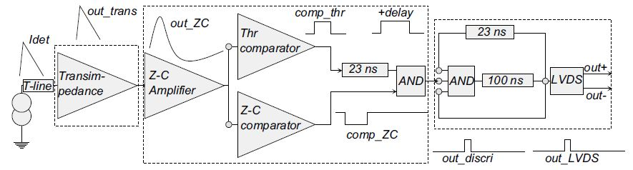

Parameters | Tested value
ASICs Technology
Number of channels
Dynamic range
Input noise (rms)
Power consumption
Power supply
Input polarity
Amplification
One shot
Discriminator
Time resolution (rms)
Time walk
Output format

2.3 Readout electronics

The readout electronics contains in total of 234 Local FPGA-based cards (16 maximum per regional crates), 16 Regional FPGA-based cards (interfaced with CRU via 2 GBT optical links) and 16 J2 bus cards between the Local and the Regional cards. One full crate consists of 16 Local cards, 1 Regional card and 1 J2 bus, and 16 similar crates are required for the entire MID readout chain.

2.3.1 Regional card

2.3.2 Local card

The local-trigger electronics (234 VME boards hosted in 16 crates) receives digital signals called "bit-pattern" sequences from the FEE (2000 cards). The main functionalities of the local cards are:

- To generate local L0 muon triggers (on single tracks above low/high p thresholds) based on the trigger algorithm located in the local card FPGAs;

- To copy the input strip-patterns stored in a memory read out at the occurrence of an ALICE trigger.

Furthermore, the local electronics calculates the track deviation in the bending plane. A minimum of three detector planes fired (out of four possible) is required. The response time is 250 ns. The local-trigger information is then sent to the regional-trigger board (1 per VME crate housing the local boards) and then to the global- trigger electronics which delivers a signal for single muons as well as for muon pairs for the whole trigger system. The total muon trigger latency is 650 ns including cable delays. It participates in the L0 of the general ALICE trigger system 8].

2.3.3 J2 backplane bus card

2.4 Timing and Trigger System

2.5 Gigabit Transceiver and Protocol

2.6 Common Readout Unit

2.7 Online Offline computing system

CHAPTER 3

Methodology

CHAPTER 4

Design and development

CHAPTER 5

Verification and testing

CHAPTER 6

Conclusion and recommendation

BIBLIOGRAPHY/REFERENCES

Brunner, H. 1972. Hieroglyphic writing: the Egyptian legacy. 3rd ed. New York, NY: Simon & Schuster.

Cape Peninsula University of Technology. n.d. Intellectual property.

http://www.cput.ac.za/polic/ip.html [15 September 2005].

Chase, J. 1979. Advertising in the modern world: an international survey. Englewood Cliffs,

NJ: Prentice-Hall.

CPUT see Cape Peninsula University of Technology.

DoE see South Africa. Department of Education.

Ellis, R. & Peters, J.P. 2000. Writing about literature. London: Macmillan

Henderson, R.S., Smith, P.G., Rossiter, I. & King, P.Q. 1987. The tenets of moral philosophy. New York, NY: Van Nostrand.

Pringle, G.S. 1982a. Aspects of style in the novels of J.M. Coetzee. College English, 35(6):34-41.

Pringle, G.S. 1982b. The novels of J.M. Coetzee. Unpublished PhD thesis, Rhodes University, Grahamstown, South Africa.

Puttnam, R.A. 1981. The place of values in a world of facts. In Duff, A. & Smithson, W.O.

(eds). The nature of the physical universe. Oxford: Oxford University Press: 45-54.

Shuttleworth, M. 2004. Interview with the researcher on 4 August 2004.

South Africa. 1982. Atomic Energy Act, No. 92 of 1982. Pretoria: Government Printer.

South Africa. Department of Education. 1995. A qualification structure for universities in South Africa. Pretoria: Department of Education.

South Africa. Department of Home Affairs. 1980. Guidelines for chairmen of publications committees. Pretoria: Department of Home Affairs.

Stewart, M.T. 1988. Should privatisation prosper? SAA in the year 1990. Cape Argus: 3, May 17.

Truter, M. 1995. The role of the court interpreter in the new South Africa. In Jansen, J.A. (ed.). Tower of Babel or Lingua Franca? Proceedings of the 1994 Conference of the South African Translators’ Institute, Bloemfontein, 18–23 June 1994. Johannesburg: SATI: 56-67

Van Aswegen, L. 2007. Library research and the Harvard method of bibliographic citation:

a research writing and style guide for postgraduate students. Cape Town: CP

If you have only one appendix, caption it Appendix. There is no need to caption one appendix as Appendix A.

If you have more than one (note the plural appendices), caption them Appendices, and list them as Appendix A, Appendix B, etc

